**Mobiles and Electronics Shop ERP**

Welcome to the Mobile Electronics Shop ERP project! This project aims to streamline inventory management and order tracking for your mobile electronics store. Below, you'll find instructions on how to navigate through the dashboard and utilize its features effectively.

**Understanding The Framework**

My project utilizes a robust stack comprising HTML, CSS, and JavaScript, along with frameworks like Bootstrap and React. Leveraging the power of React, I've integrated Redux for state management, along with Formik and Yup for streamlined form handling.

To enhance the visual appeal and functionality, I've incorporated popular icon libraries such as Font Awesome, hugeIcons, and Flaticons, ensuring a rich and dynamic user experience*.*

**Dashboard Navigation**

The dashboard consists of several main sections:

**1. Dashboard**

The Dashboard section provides an overview of key metrics for your business. Here, you can track important indicators such as total sales, inventory status, and order fulfillment rate at a glance.

Add Dashboard Screenshot and explain every point

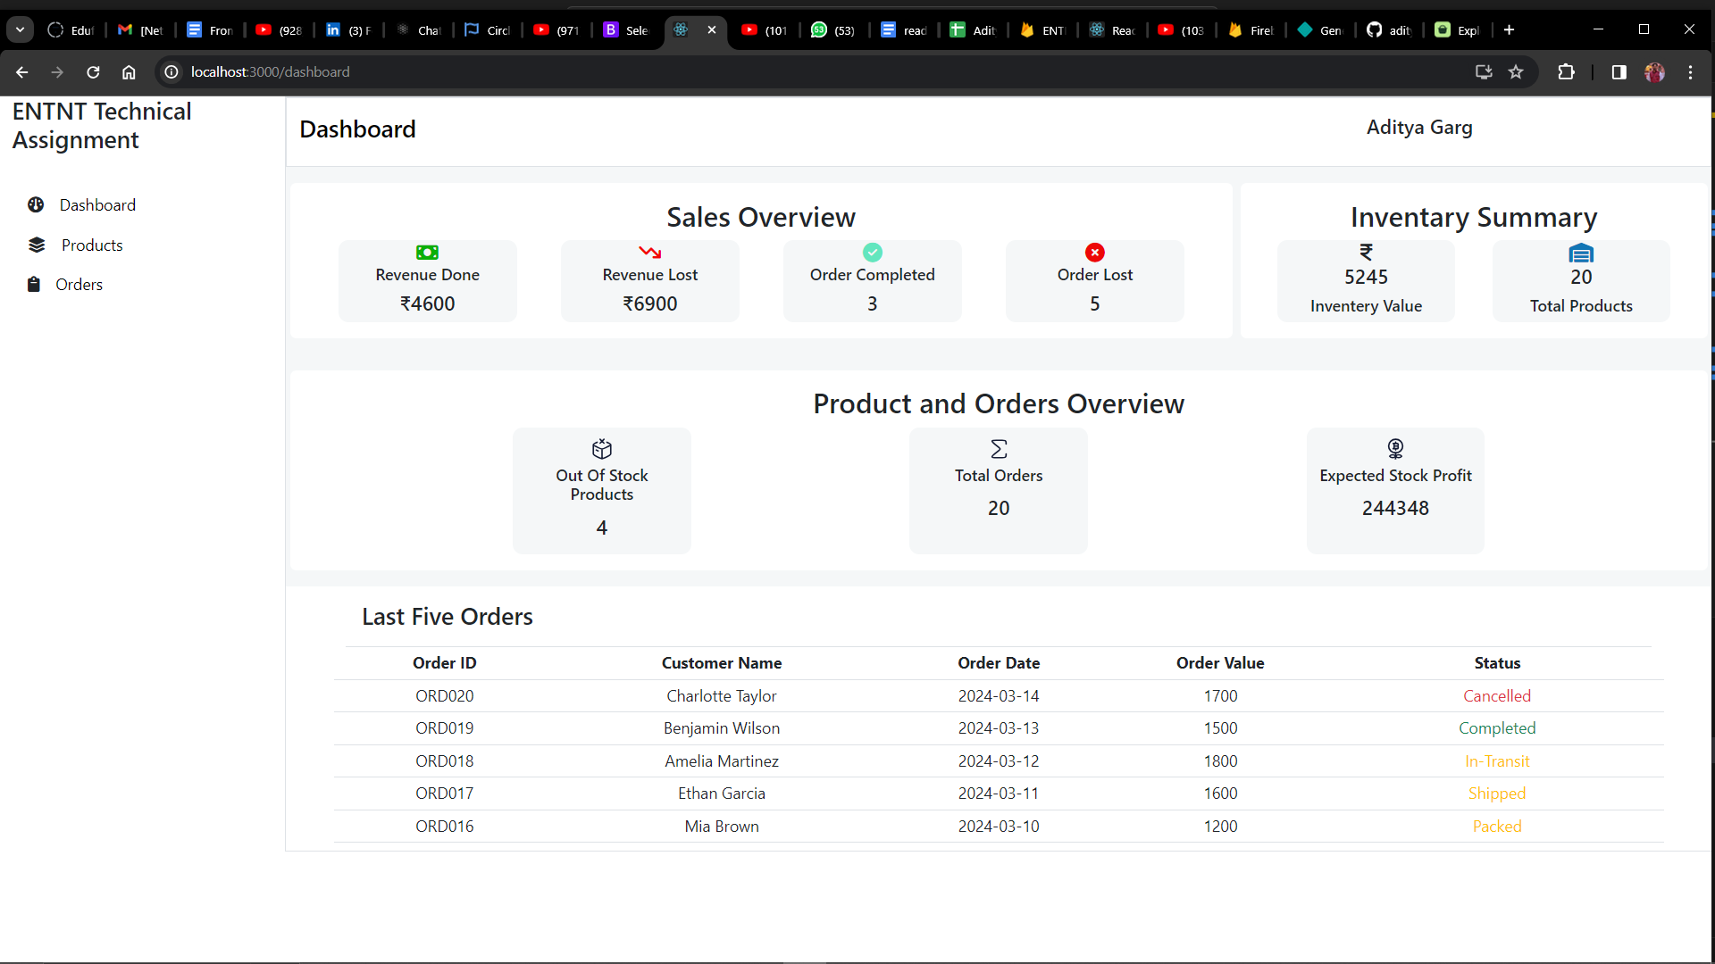

| **Metrics** | **Explanation** |
| --- | --- |
| Sales Overview | Revenue Done - Sum of Order value of orders which are completed Revenue Lost - Sum of Order value of order which are lost Order Completed - Numbers of orders which are completed Orders Lost - Number of orders which are lost (canceled, returned) |
| Product & Orders Overview | Out of stock product - product which are not in stock Total Orders - Total number of order Expected Stock Profit - (Sum of Selling Price - Sum of Cost Price of all product) |
| Last 5 Order | Last 5 orders in orderbook |

**2. Products**

In the Products section, you can manage your inventory effectively. Here's what you can do:

1. View Inventory Summary: Check the summary of your current inventory, including the total number of products and their availability status.
2. List of Products: See a detailed list of all products, including their names, quantities, and stock availability.
3. Add New Product: Add a new product to your inventory.
4. Update Existing Product: Edit the details of an existing product, such as its name, quantity, or price.
5. Delete Product: Remove a product from your inventory.

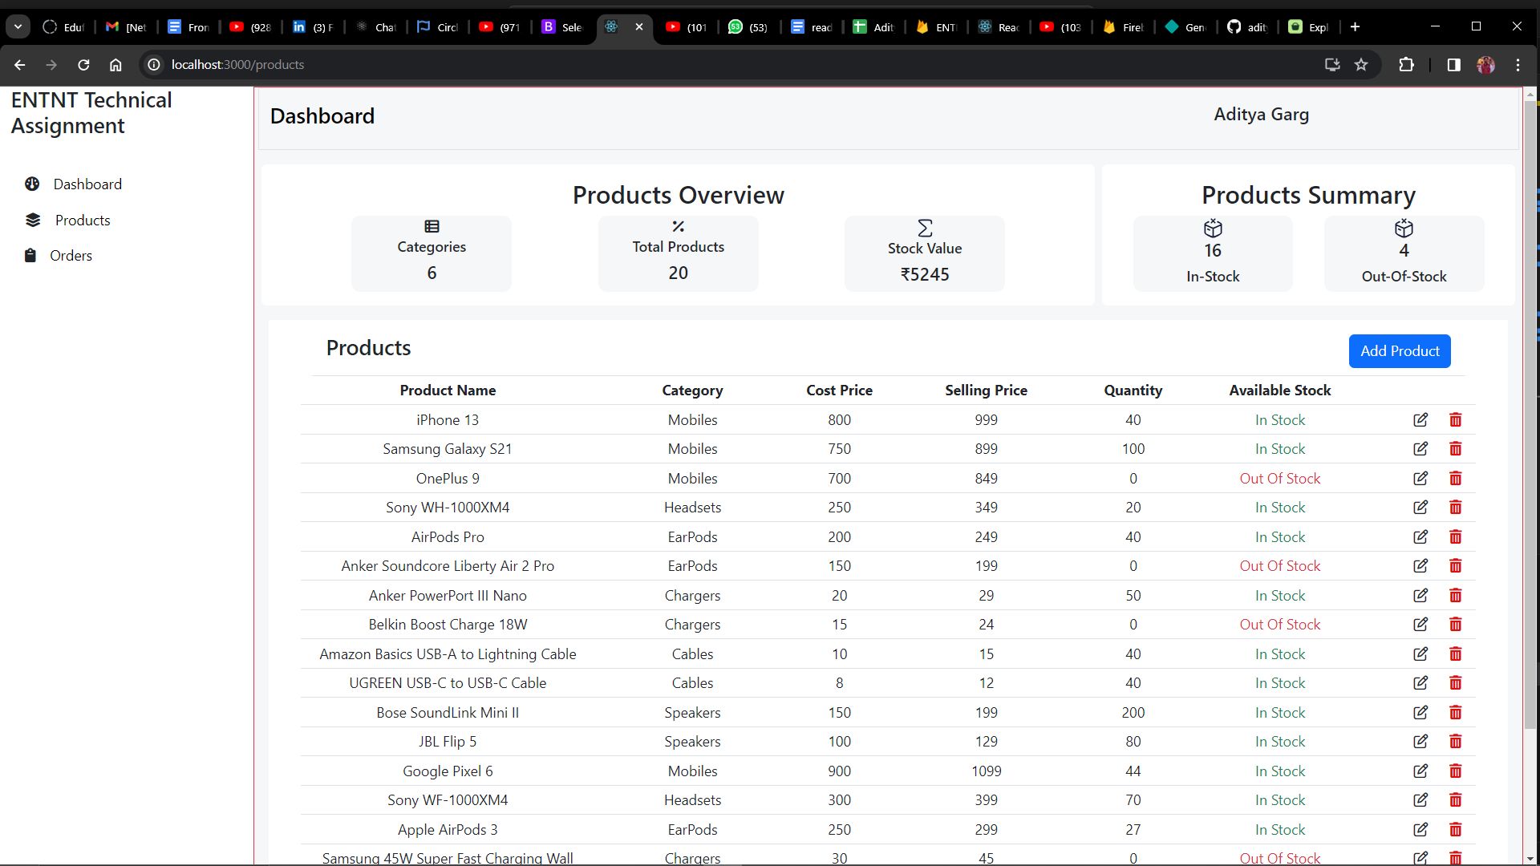

Fig. Product Listing Page

| **Flows** | **Remark** |
| --- | --- |
| Add Product | Here we see a button on the right side in the screenshot . By clicking on this we can add a New Product. After clicking on that it shows the product form |
| Edit Pencil Icon | Here we see an icon on the right side in the table in the screenshot . By clicking on this we can Edit Product. After clicking on that it takes us to the product form in which details are pre-populated. |
| Trash Icon | Here we see an icon on the right side in the table in the screenshot . By clicking on this we can Delete Product. After clicking on that a popup sees on the screen and there we see a delete button in red background and close button in grey background. |

**Add Product Flow**



On product page click orde Add order button and enter details in the Add Product Form

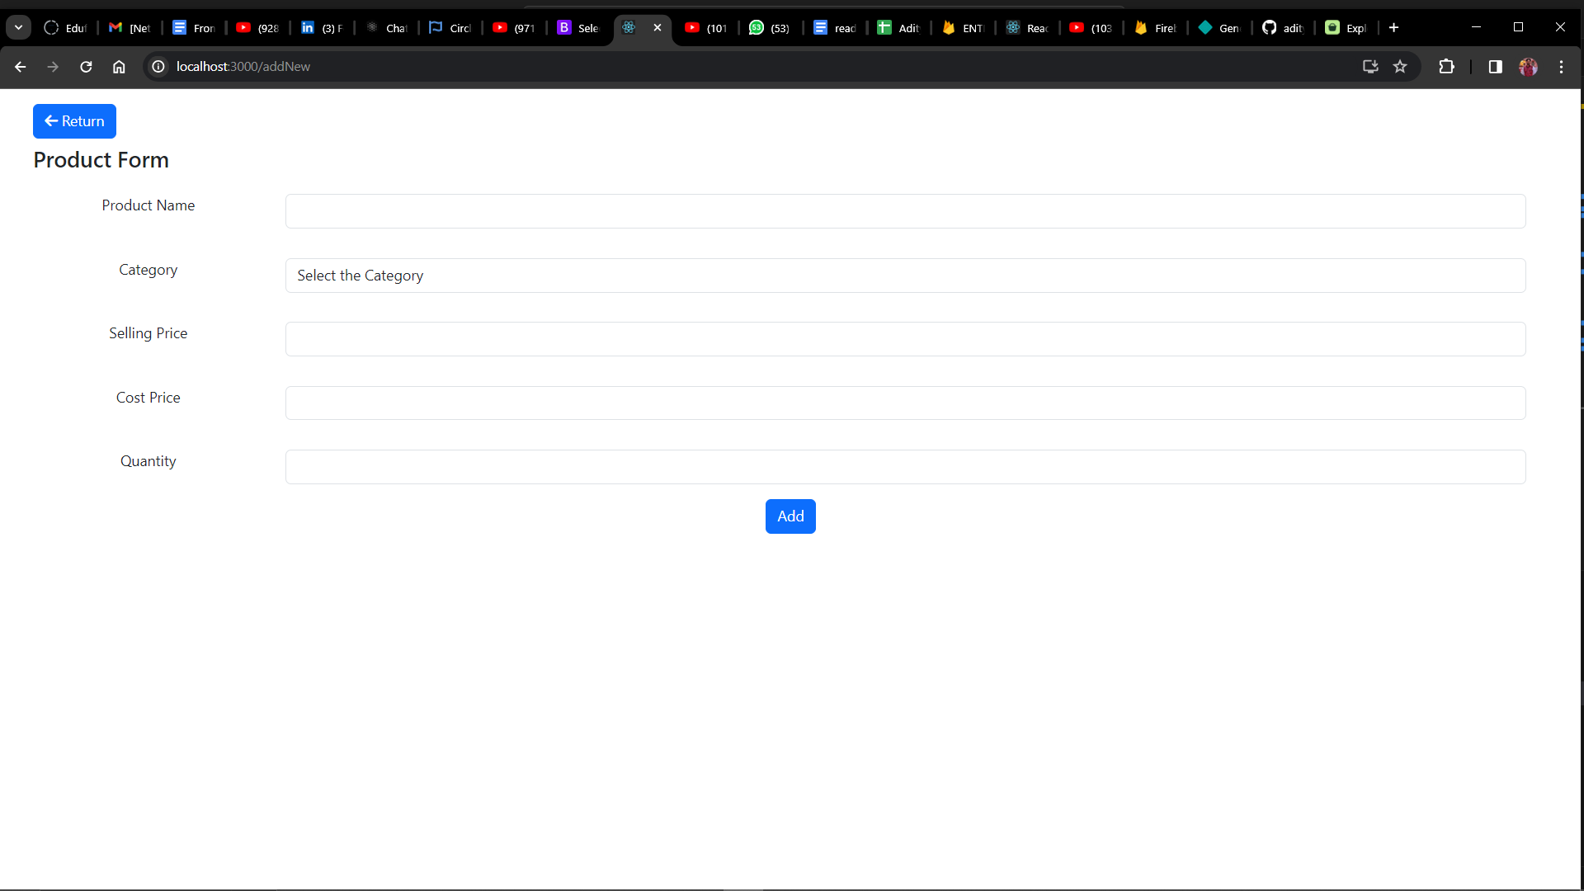

Fig. Add Product Form

**Delete Product**



Click on delete icon and answer the popup as per your requirement. And click on delete button to confirm and Close button to cancel the operation

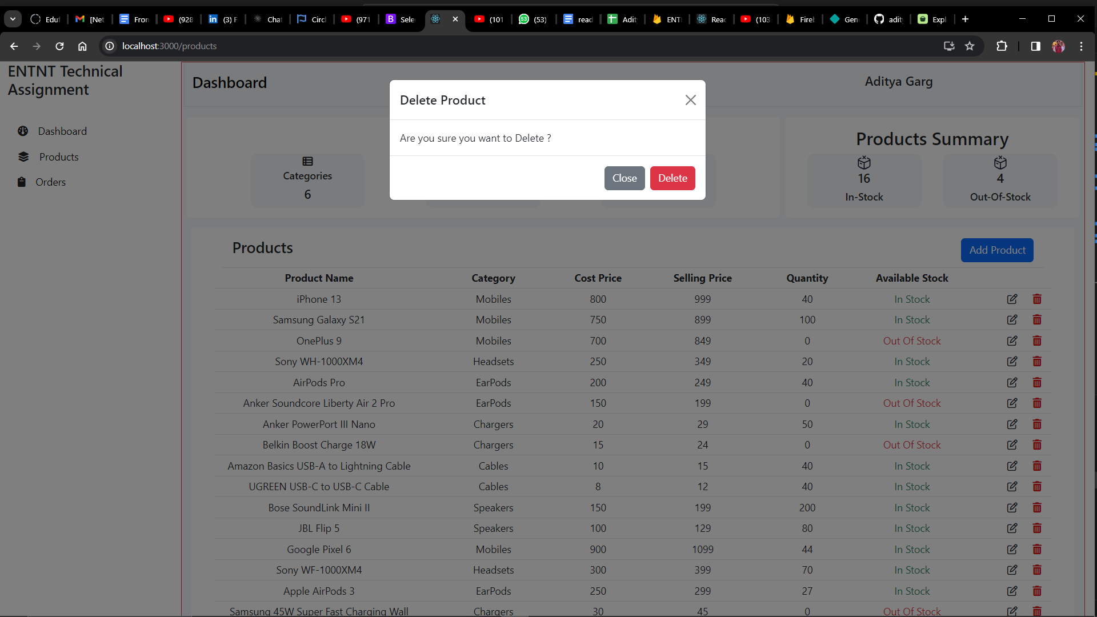

Fig. Delete Overlay

**3. Orders Page**

The Orders section helps you track and manage customer orders efficiently. Here's what you can do:

1. Order Summary: Get an overview of all orders, including their status and total value.
2. List of Orders: View a detailed list of all orders, including the customer's name, order ID, status, and total value.
3. Update Order Status: Change the status of an order, such as from 'Pending' to 'Completed'.
4. Delete Order: Remove an order from the system if needed.

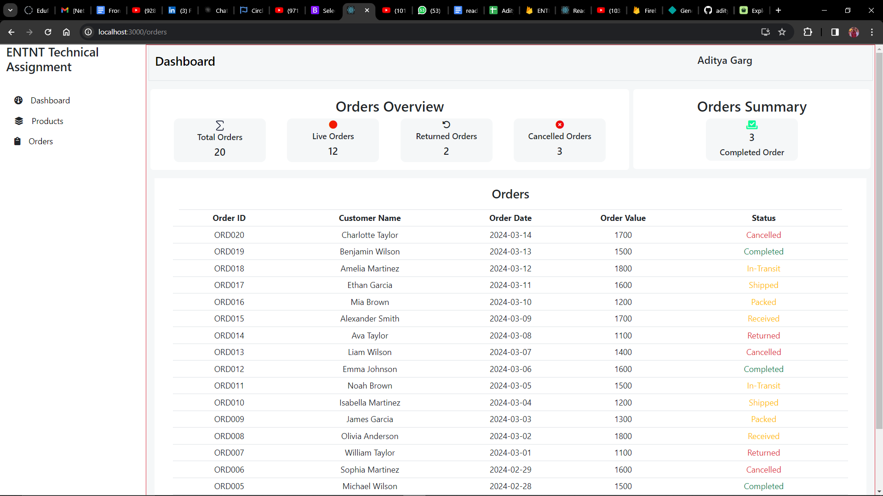

| **Metrics** | **Explanation** |
| --- | --- |
| Total order | Total number of orders in order book |
| Live Order | Orders which are in transit |
| Returned Order | Orders which are returned by the customer |
| Canceled Orders | Orders which are canceled by the customer |

**Update Status Order Flow**

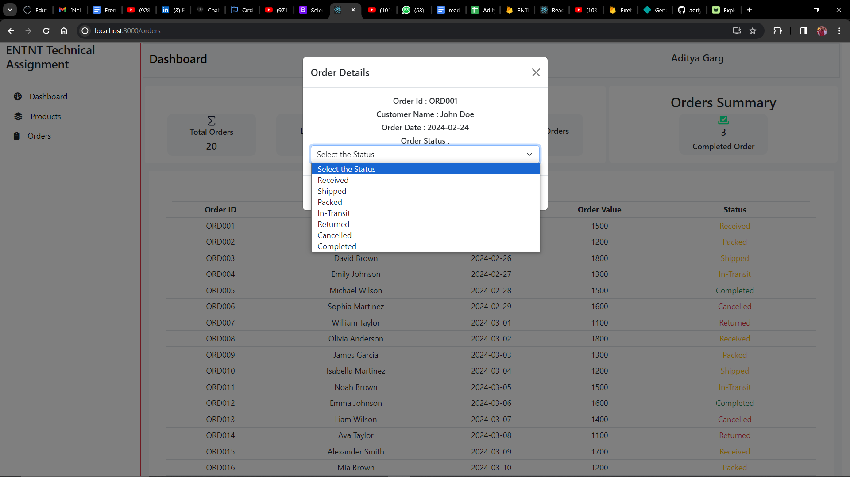

Click order order in list and order detail overlay will appear. Users can update the status and Click on change status

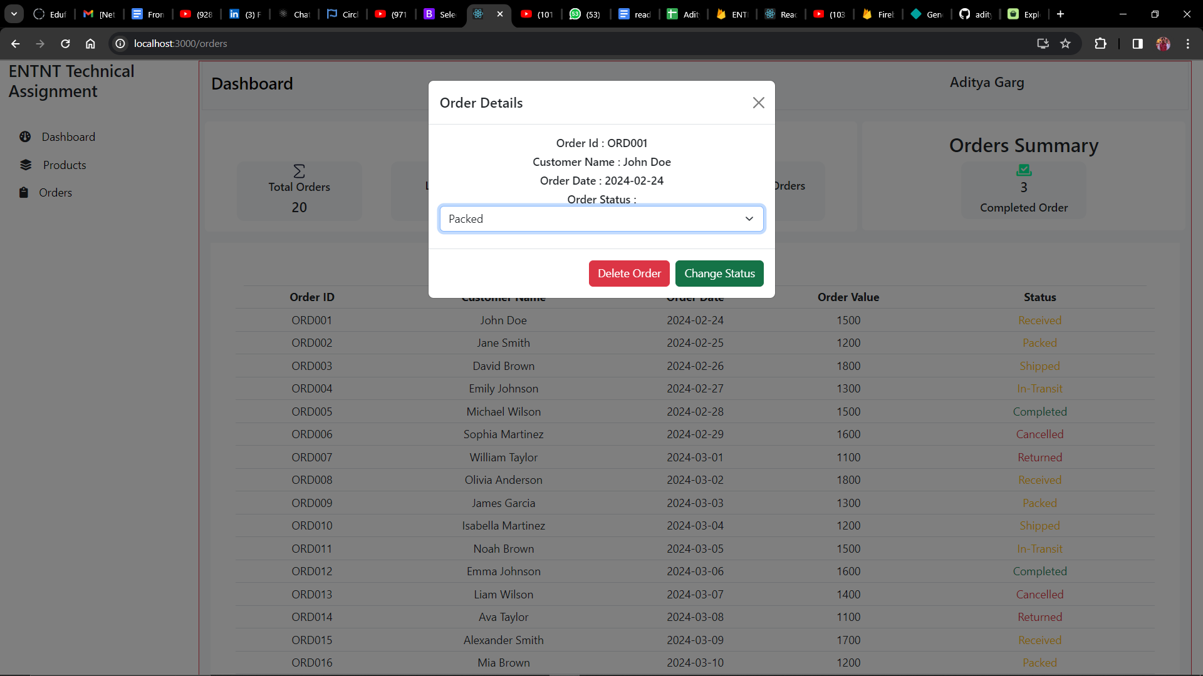

Fig. Update Status Overlay

**Order Deletion Flow**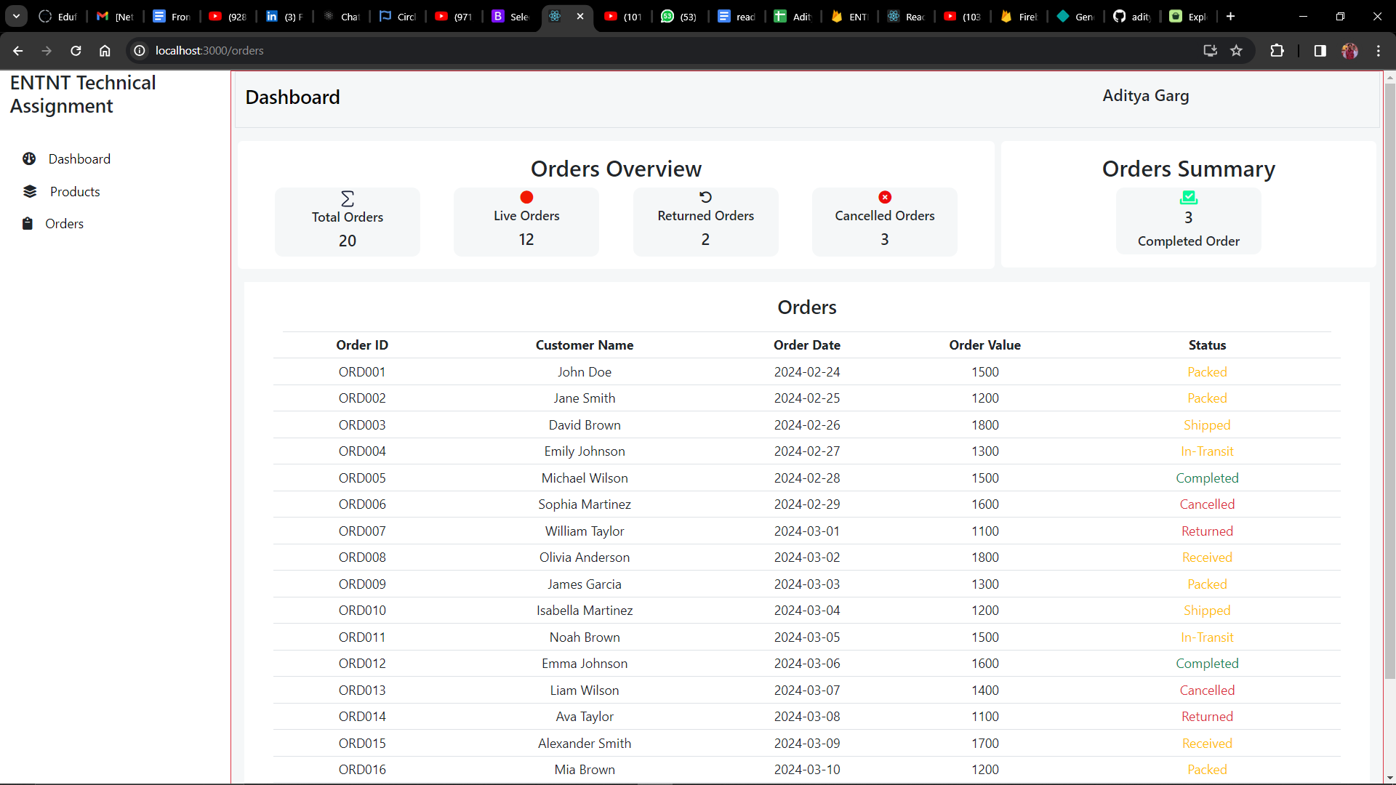

Select order and click on delete order in the order details overlay. Click on delete to delete order and close button to close the operation

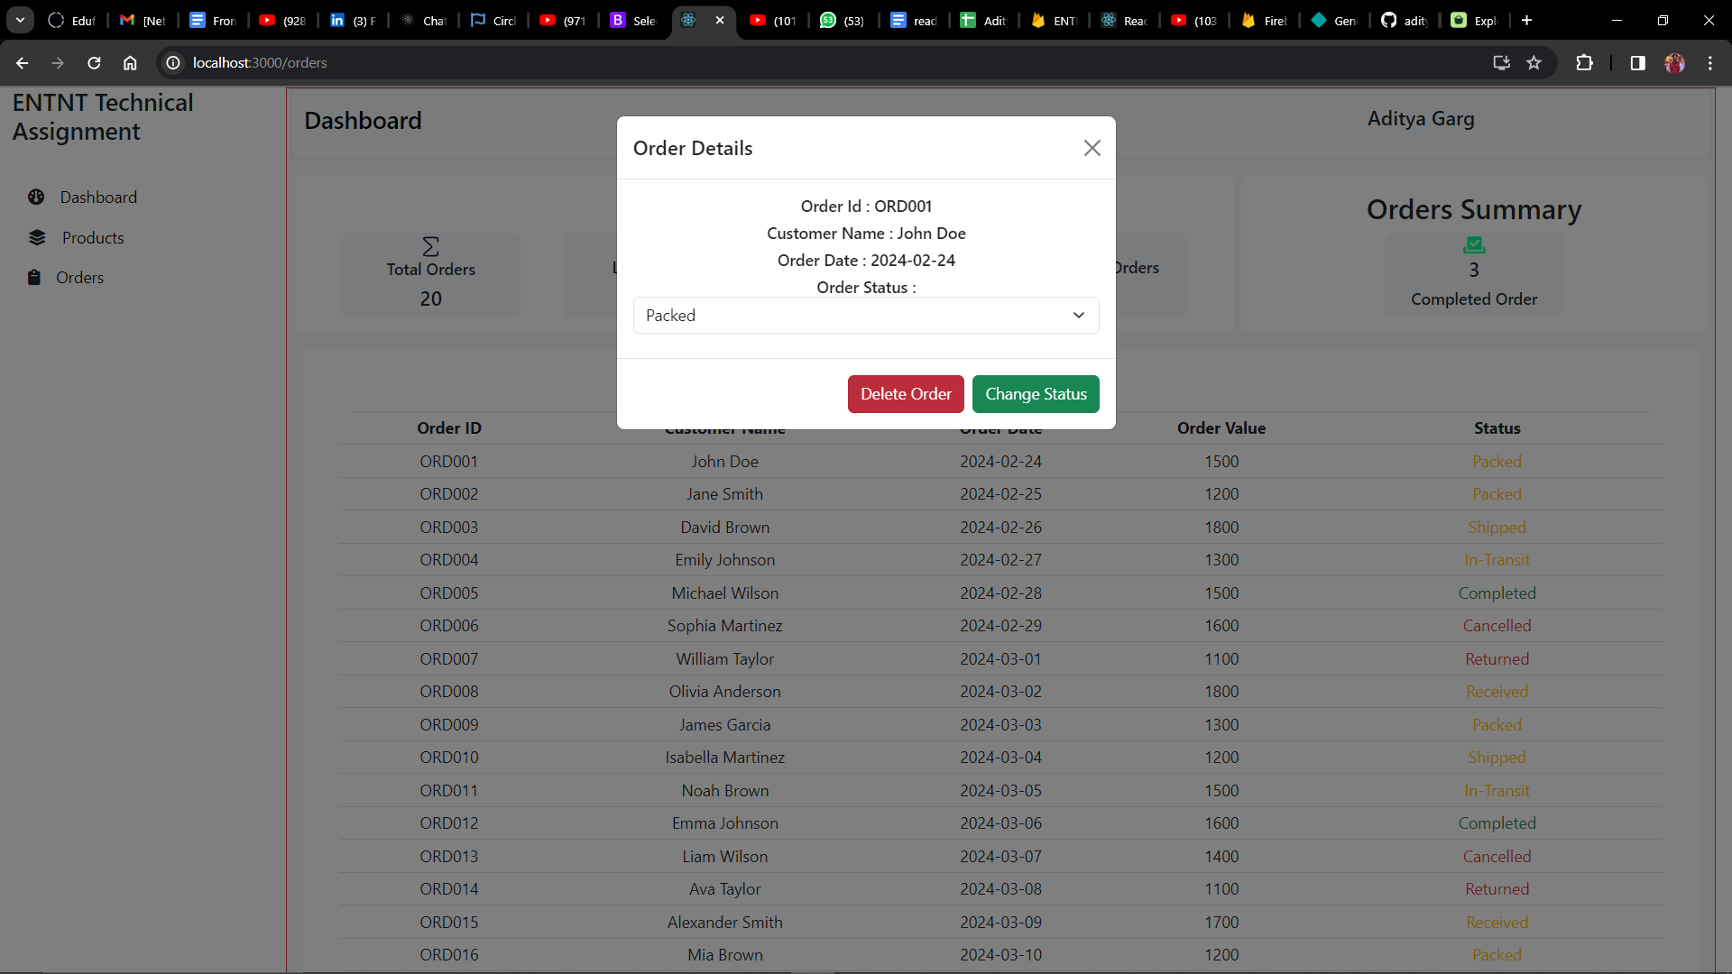

Fig. Delete Order Overlay

**Contact**

If you have any questions or need further assistance, you can reach out to the project maintainer at [adityagupta199818@gmail.com](mailto:adityagupta199818@gmail.com).